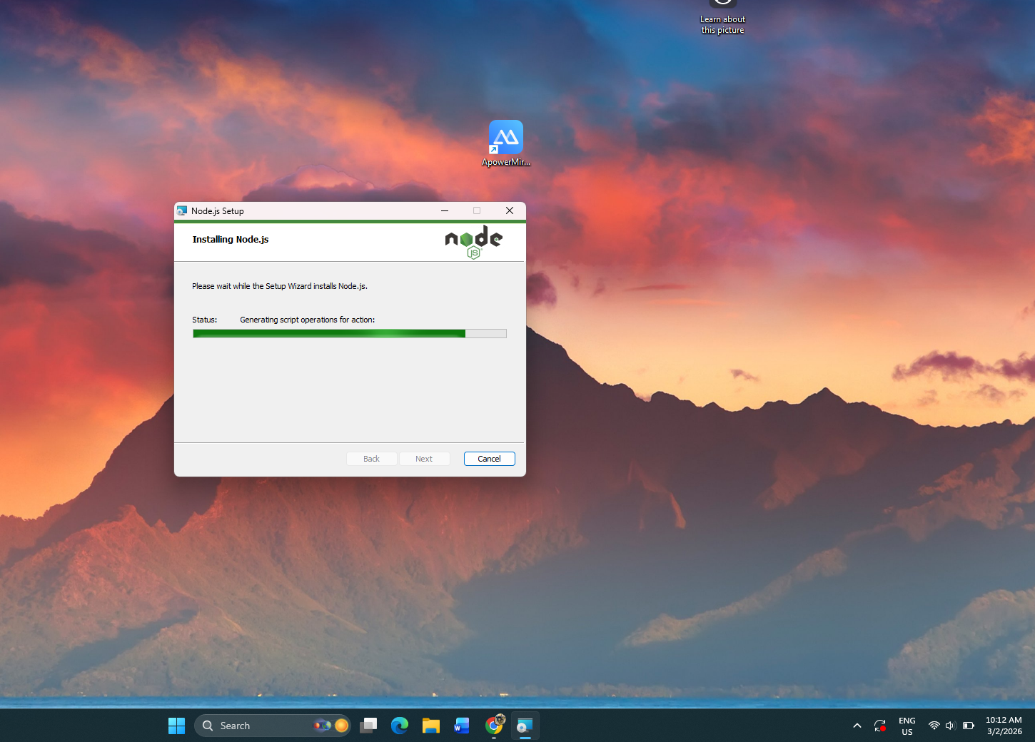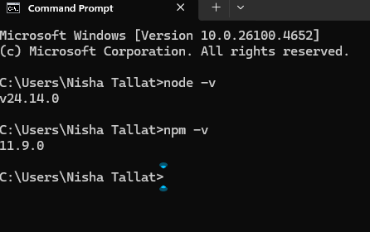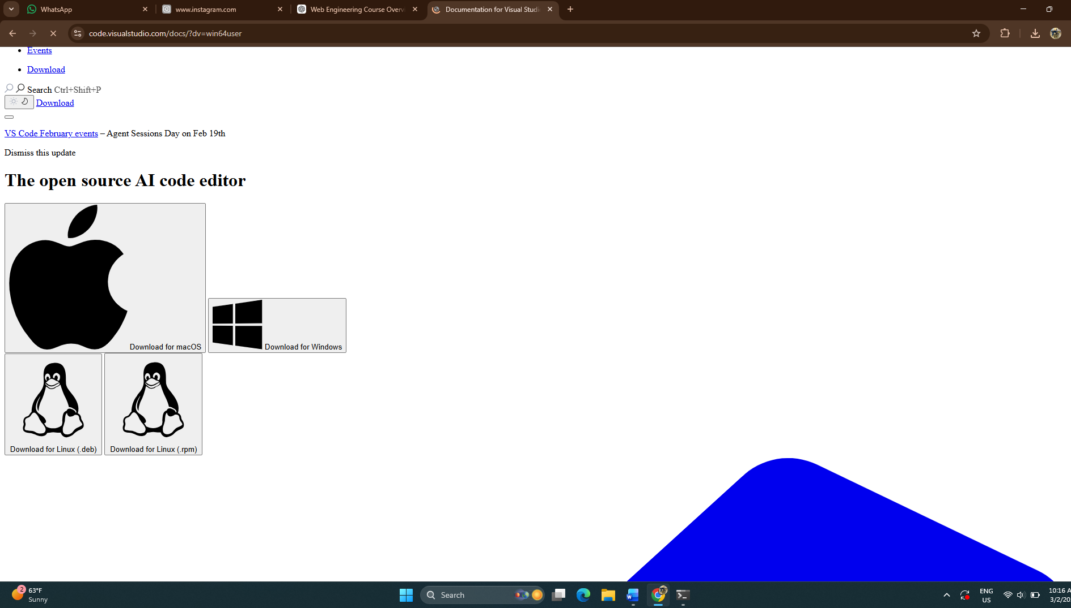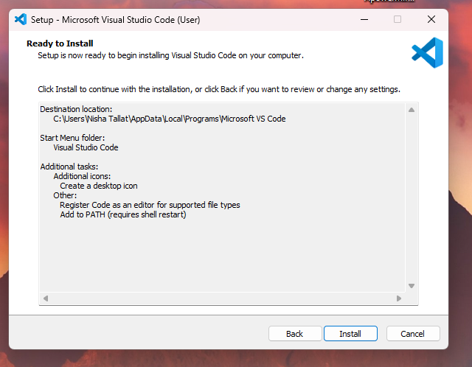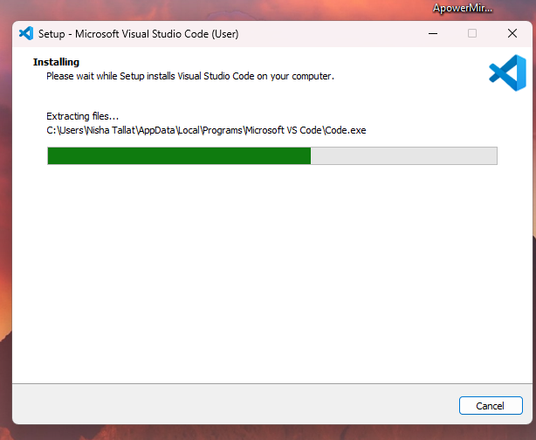

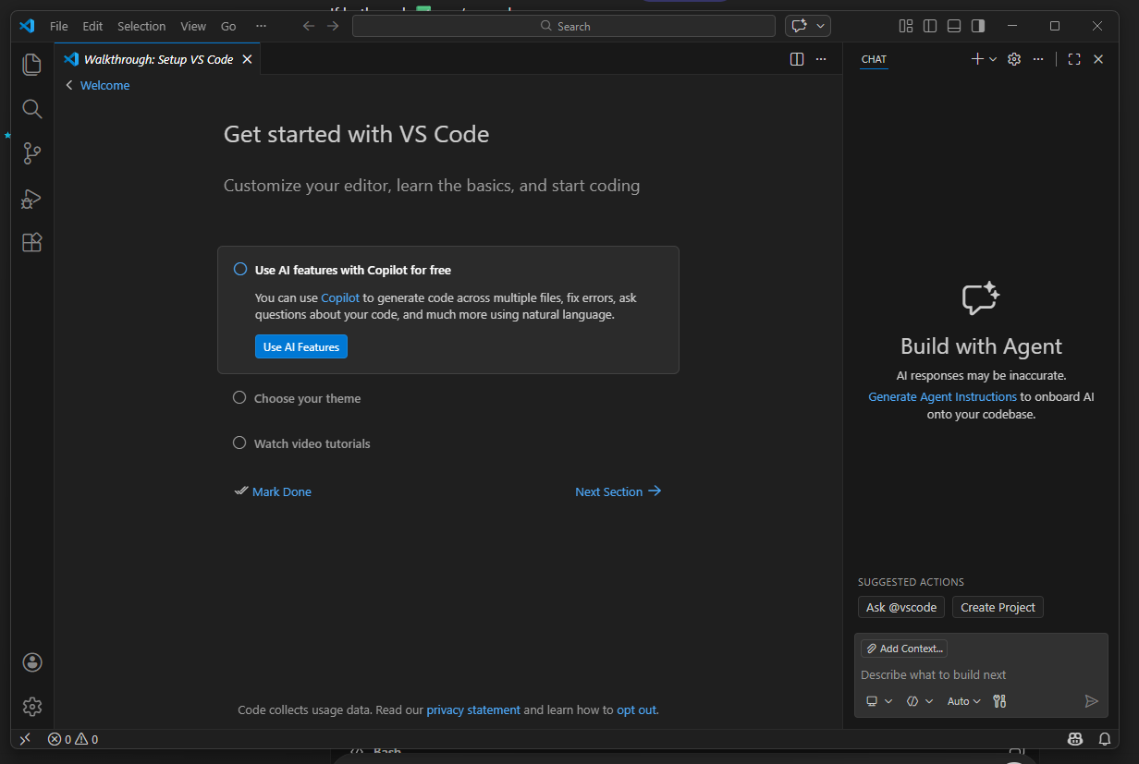
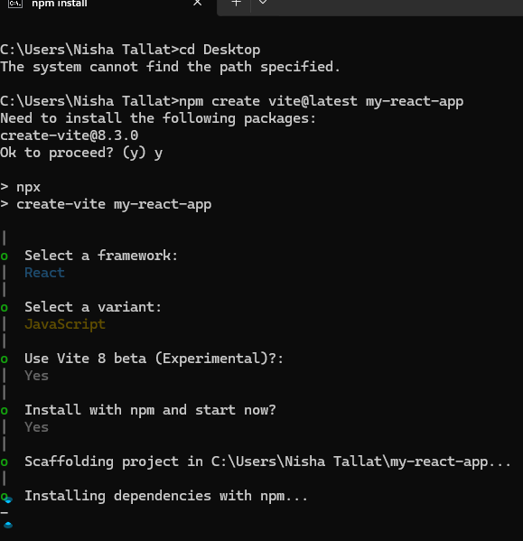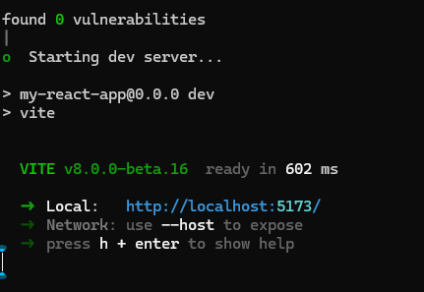
http://localhost:5173/

import { useState } from 'react'
import reactLogo from './assets/react.svg'
import viteLogo from '/vite.svg'
import './App.css'

function App() {
const [count, setCount] = useState(0)

return (
<>
<div>
<a href="https://vite.dev" target="_blank">
<img src={viteLogo} className="logo" alt="Vite logo" />
</a>
<a href="https://react.dev" target="_blank">
<img src={reactLogo} className="logo react" alt="React logo" />
</a>
</div>
<h1>Vite + React</h1>
<div className="card">
<button onClick={() => setCount((count) => count + 1)}>
count is {count}
</button>
<p>
Edit <code>src/App.jsx</code> and save to test HMR
</p>
</div>
<p className="read-the-docs">
Click on the Vite and React logos to learn more
</p>
</>
)
}

export default App

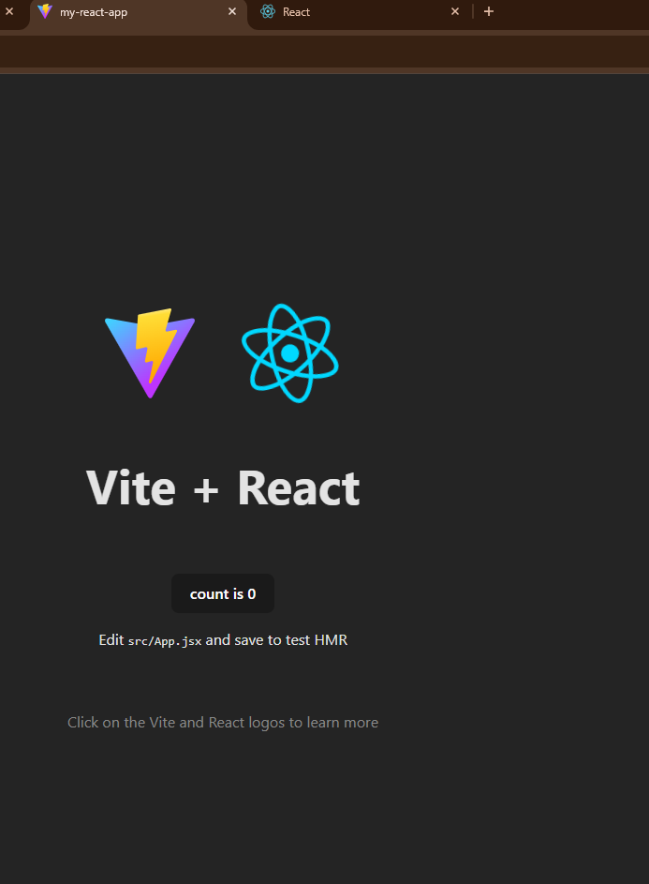

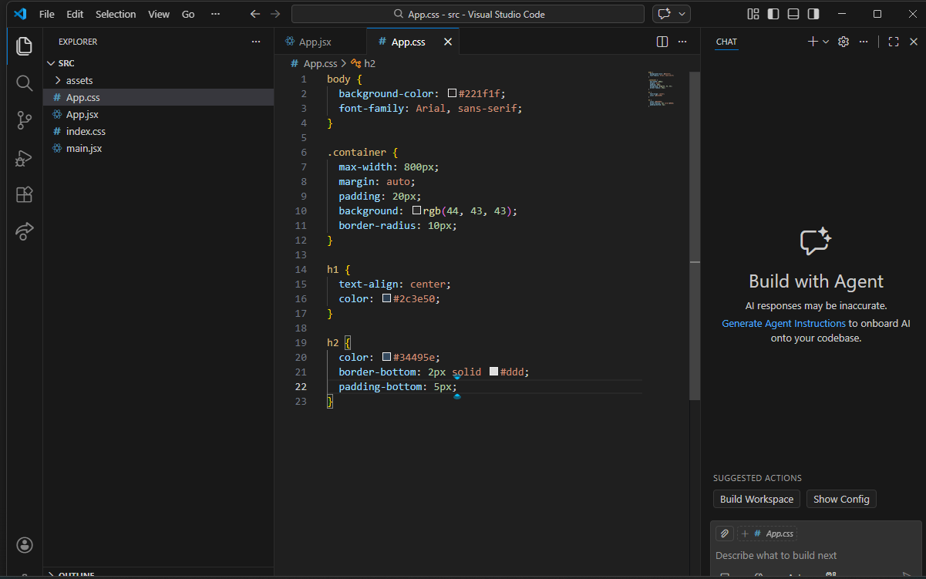

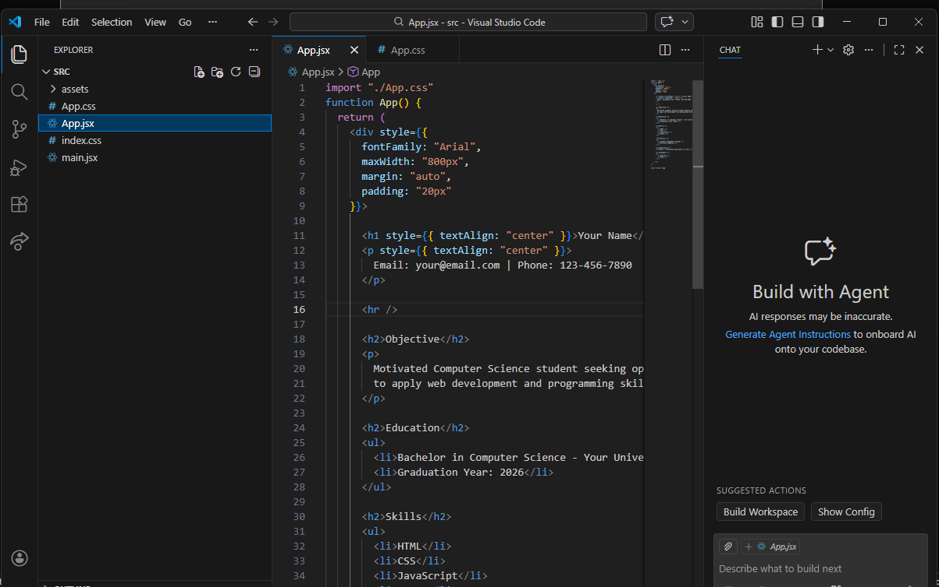

Respected Sir/Madam,
My name is Abdullah Tallat (Registration No. BSSEO12315010), a student of BS Software Engineering, currently enrolled in the 6th semester.
I would like to request withdrawal from all my registered courses for the current semester. The reason for this request is that I am planning to go abroad for further studies, therefore I will not be able to continue my courses this semester.
I kindly request you to please process my course withdrawal from all subjects on the online portal.
I shall be very thankful for your cooperation.
Sincerely,
Abdullah Tallat
Registration No: BSSEO12315010
BS Software Engineering – 6th Semester
Date: 16 March 2026
Software Risk Management Theory+Lab
Software Construction and Development Theory+Lab
Web Engineering Theory+Lab
Machine Learning Theory+Lab
Human Computer Interaction and Computer Graphics Theory+Lab
Parallel and Distributed Computing Theory+Lab

